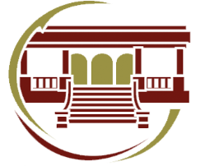

Centro Cultural de Salinas
Interior Muralla S/N
Tel. (496) 96-3-01-08
